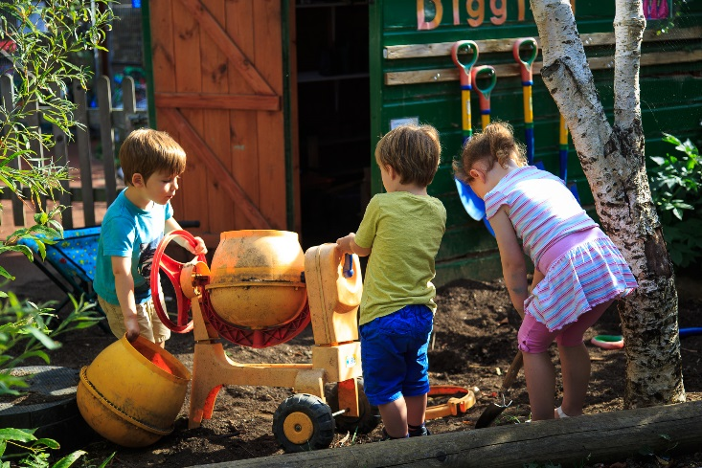

**Person Specification**

**Early Years Teacher**

|  |
| --- |
| **Education & Experience**  Person Specification |
| 1. Qualified teacher status. 2. Successful experience of working within an early years setting. 3. Experience of working with children who have additional needs is desirable. |
| **Knowledge, Skills & Ability** |
| 1. Demonstrate the ability to safeguard and promote the welfare of children and provide a safe learning environment and recognize when a child is in danger or at risk of abuse. 2. A sound knowledge of child development, early childhood education, current early years policy and issues including the importance of early intervention and integrated working. 3. Excellent knowledge and understanding of the educational, developmental and health needs of children under 5 including those with SEND and how to implement the statutory learning, assessment, welfare and safeguarding requirements of the EYFS. 4. Knowledge and ability to meet the needs and improve outcomes for children through appropriate curriculum planning, differentiation, assessment, tracking and record-keeping. 5. Ability to create and maintain a high quality learning environment which supports the development of strong characteristics of learning across all areas and in which children can thrive particularly in the areas of, personal, social and emotional development and well-being. 6. Ability to foster equality and promote the richness of diversity through the curriculum, in relationship with parents, and in the supervision, support and leadership of staff. 7. Ability to be reflective and evaluate provision through insightful analysis of qualitative and quantitative data and initiate appropriate changes. 8. Knowledge and understanding of, the importance of mainstream educational inclusion for children with special educational needs. 9. Ability to lead or a commitment to developing the ability to lead, manage and motivate staff. 10. Commitment to maintaining and developing the ethos of the nursery as a partnership of children, staff, parents/carers, governors and the community. 11. Highly effective communication, interpersonal and emotional intelligence skills which support facilitate trust and positive relationships with staff, parents, children and partners. 12. Understanding of the importance of appropriate information sharing and confidentiality in supporting children’s and families well-being. 13. Strong knowledge and understanding of and ability to work in accordance with local and national safeguarding procedures. |
| **Commitment To Equal Opportunities** |
| 1. Ability to adhere to the Council’s Dignity for All policy. |
| **Special Requirements Of The Post** |
| 1. This role will require you to obtain an Enhanced satisfactory clearance from the Disclosure and Barring Service formally known as the Criminal Records Bureau (CRB) Disclosure. |

**8**