Job description

## **Practice Development Manager**

* Grade: P05/6
* Reports to: Principal Child and Families Social Worker
* Your team: Workforce Development Team
* Service area: Safeguarding and Family Support
* Directorate: Children and Young People

|  |
| --- |
| Special requirements of the post |
| Workstyle: Roaming (Medium presence, two days a week) |
| This post requires a DBS check at the appropriate level: Basic |
| This post is subject to the council’s declaration of interest procedure |
| This post is designated as politically restricted |

## Our mission

Islington is a place rich with diversity and culture. As a council our sense of purpose couldn’t be clearer: we serve. It’s in the logo. We are committed to challenging inequality in the borough and as one of the largest employers we know that to look after the place and the planet, we have to look after our people. **Together we can change the future**.

To do this, everyone who works at Islington Council lives by a set of values which guide us in everything that we do: collaborative, ambitious, resourceful, and empowering. They spell out ‘CARE’, which is what we think public service is all about.

## Overview of the role

As a member of the council’s management team, to contribute proactively to the collective leadership for the council, working collaboratively with Members, services across the council, partners and stakeholders to deliver the council’s objectives and priorities.

To drive positive cultural change, embodying and promoting the values and behaviours of the council and empowering staff to reach their full potential. Ensure that the performance and development framework is effective for all staff.

To lead on and ensure the effective implementation of corporate initiatives and transformation programmes that cut across the whole or part of the council’s activities.

Lead on the development, implementation, delivery and evaluation of the workforce / practice development plans in Family Help and Safeguarding to meet the requirements of the Children’s Social Care National Framework, Early Career Framework and Islington’s Motivational Practice model.

To lead on identified projects and programmes within the Workforce Development Team, using your practice expertise to plan and influence projects that lead to measurable improvement in skills in all practice and service delivery areas.

Advise and support senior managers to create the culture and conditions for excellent practice in children’s social care through training, coaching, and role-modelling in its services to children, young people and their families.

Contribute to the development of programmes that meet the requirements of *Social Work England* that prepare social workers to meet the standards of practice set out in guidance (e.g. Post Qualifying Standards, Knowledge and Skills Statements etc) and that give social workers evidence-informed practice skills to do their work effectively.

## Share responsibility for managing budgets, commissioning services, and holding oversight for the training and practice development programme for Family Help and safeguarding.

## Key responsibilities

* Work with senior leadership team, to develop and implement training and workforce / practice development plans for designated service area(s) to:
  + meet national and professional CPD requirements
  + address service and funding priorities
  + support service developments, practice development and workforce reforms.
  + encourage behaviours and skills aligned to the Motivational Practice Model and practice in general.
* Liaise with colleagues in family help and safeguarding, education, health and the private, voluntary and community sectors to develop a cohesive workforce /practice development strategy and plan that supports the Council's Children and Young People's Plan and Corporate Delivery Plans.
* Provide practice learning and practice development opportunities defined by the plan, either through commissioning or direct delivery of programmes.
* Uphold high standards in developing and delivering training that is effective in supporting the social care workforce’s continuous professional and practice development.
* Evaluate outcomes and impact of workforce and practice development activity against statutory guidance (e.g. National Social Care Framework), Post Qualifying Standards, Knowledge and Skills Statement, Motivational Practice Model, and feedback from stakeholders.
* Work with senior leaders to support their engagement in organisational development and practice learning opportunities for their staff.
* Manage all aspects of commissioning and monitoring external training / practice development providers, including provider specifications and performance indicators, tendering and tender evaluation, and contracting.
* Develop and manage qualification policies and programmes relevant to children social care, maintaining constructive partnerships with other boroughs, HEIs, and awarding bodies to achieve and maintain awareness of these schemes.
* Manage relevant budgets, ensuring that resources are used to best effect and resource limits not exceeded.
* Ensure appropriate arrangements are in place to bid for, obtain, and monitor, funding for professional, government-resourced learning, training and practice development schemes.
* Provide information and reports to members, senior managers, funding bodies or for other purposes as required
* Any additional duties consistent with the grade and level of responsibility of this position, for which the holder possesses the required experience and/or training.

### Budget responsibilities

### Ensure effective management of the team budget and that resources are well managed and effectively deployed to the best possible effects assuring value for money in all activities

### Compliance

Ensure adherence to legal, regulatory, and policy requirements under GDPR, Health and Safety, Employee Code of Conduct and in your area of expertise by identifying opportunities and risks, and escalating issues as necessary.

## Person specification

Your application form needs to demonstrate how you fulfil the role's requirements. It is essential to address the criteria, as this will be used to evaluate your suitability for the position.

### Essential and desirable criteria

|  |  |  |
| --- | --- | --- |
| Point | Criteria description | Essential/desirable |
| 1 | Extensive experience in a children social care role, with a level 5/6 qualification in social work. | Essential |
| 2 | Extensive experience of working in a learning / development environment in the public sector, local government or national organisations. | Essential |
| 3 | Sound knowledge of national developments and the reform agenda for the children social care workforce | Essential |
| 4 | A good understanding of current practice themes in children’s social care | Essential |
| 5 | Experience of managing learning and practice development opportunities | Essential |
| 6 | Experience of strategic multi-agency and partnership working | Essential |
| 7 | Excellent presentation, communication and facilitation skills | Essential |
| 8 | Ability to devise workforce, learning, and practice development plans that reflect a strong understanding of skilful practice, current legislation, and emerging areas of focus in children social care. | Essential |
| 9 | Good analytical skills, ability to interpret data and devise development and action plans based on results | Essential |
| 10 | Proven ability to build good working relationships with colleagues, internally and external to the department. | Essential |
| 11 | Proven ability to manage budgets and projects | Essential |

## **Our accreditations**

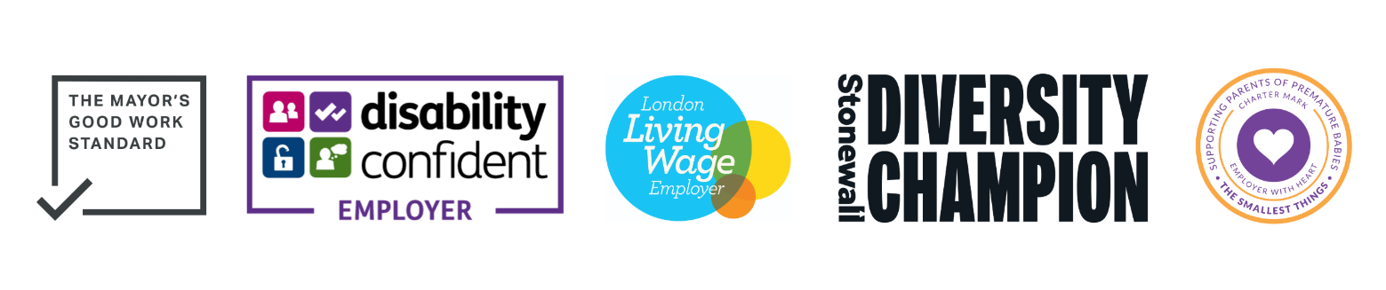

Our accreditations include: The Mayor’s Good Work Standard, Disability Confident Employer, London Living Wage Employer, Stonewall Diversity Champion, and Employer with Heart.