

EYFS Class Teacher
Tufnell Park Primary School

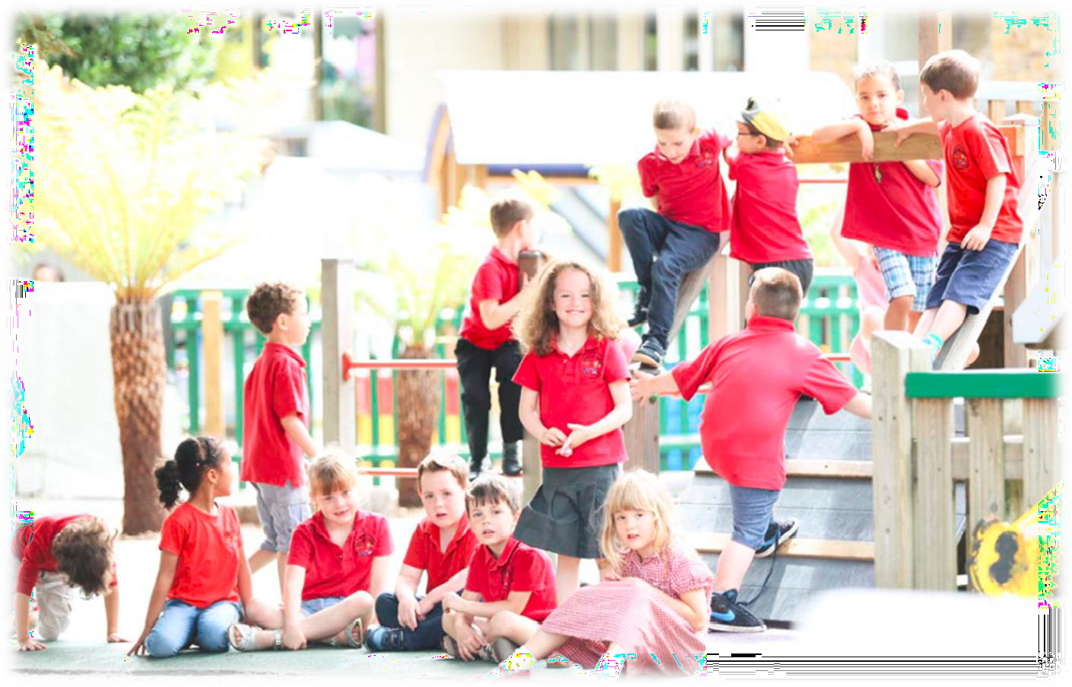

Closing Date: 9am on 13th May 2026


Contents page

Letter from the Headteacher | 3
About the School | 4
Advert | 6
Job Description | 8
Person Specification | 11
Additional Information | 13

 | Tufnell Park Primary School  31 Carleton Road, London N7 0HJ admin@tufnellpark.islington.sch.uk  020 7607 4852

Dear Applicant,

I am delighted that you are interested in joining the team here at Tufnell Park. I would like to take this opportunity to tell you a little more about our school.

Tufnell Park is a happy and dynamic primary school with nursery. Following expansion, we are now two forms of entry throughout, plus a 26FTE Nursery and provision for two-year-olds. Most classes are full with waiting lists, bucking current trends for falling rolls.

Exciting times are ahead for those who join our team. We have a stunning new building, with state of the art facilities reflecting the high aspirations we hold for our community. Everything we do is driven by an inclusive approach; we have a deep understanding of our families, their aspirations and skills, and their needs and challenges, and we ensure every experience for every child is shaped with these in mind.
We are therefore looking for staff who, like our current team, are skilled at adapting learning experiences by working imaginatively yet rigorously, and motivated by developing truly inclusive environments and practice.

Though we are a good school with consistently strong outcomes, we have high aspirations to improve in all areas, and the capacity to do so. Our curriculum is continually evolving to address the needs and aspirations of our children alongside the demands of a changing world, so we are seeking staff with the drive and creative spark to devise and shape rich and purposeful experiences that ensure all our children become responsible, resourceful, and resilient citizens.
Our children come from a wide range of backgrounds, including a number of families in challenging circumstances. Our team works together to ensure that we build an inclusive and cohesive community, all of whom aspire to achieve the very best for our children and our school. This makes Tufnell Park a rewarding place to work.

If you have the drive and ambition, many varied opportunities exist to be part of shaping the future here at Tufnell Park, whilst developing your own practice and career. You can expect from us a commitment to your own professional development, a supportive leadership team and a wonderful group of teaching and support staff, who really believe in our children and their ability to succeed. We are well supported by a very effective governing body and an active Parent Teacher Association, ensuring our community is fully engaged in the life of the school.

I would love for you to visit us and get a sense of what Tufnell Park is all about. Please call or email me (via admin@tufnellpark.islington.sch.uk) to make an appointment. I look forward to hearing from you. I look forward to hearing from you,
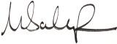
Martin Scarborough – Headteacher

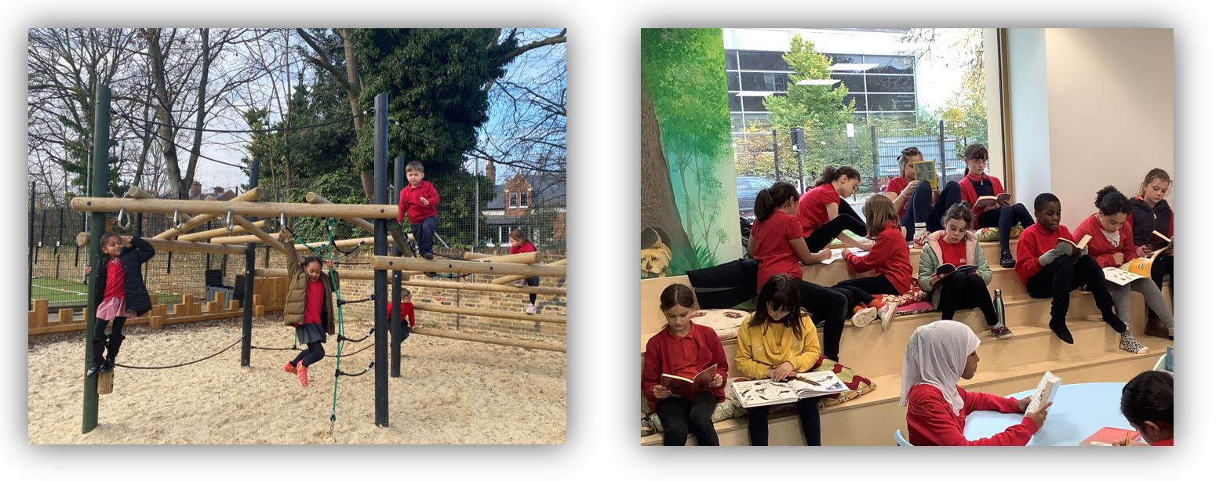

About the school

Tufnell Park is a great place to work and is a positive environment where everybody works together to achieve.

Our site on the brow of a hill gives wonderful views across North London—big skies and wide horizons are always in evidence. We are surrounded by natural wildlife spaces and mature trees, so we are able to enjoy a peaceful and containing space that brings us close to nature, whilst still being only minutes away from the heart of London and all that offers.

We are situated in area of wide-ranging social context, between areas of Victorian housing and established local authority housing estates, making our intake diverse and fully reflective of the local community. 41% children come from minority ethnic families, and 31% speak English as an additional language, with over 30 home languages represented. The school has higher than average mobility compared to schools nationally, with some children arriving from overseas, often with no English and little/no formal education.

In September 2019 we moved into a brand-new building with additional dedicated facilities, including a SEN suite with sensory rooms, teaching kitchen, a music/dance studio, and a large AstroTurf sports pitch. Ambitious plans and funding are in place to further develop both our indoor and outdoor

environments, to increase access and facilitate greater inclusive practice for all.

The school has an excellent and committed staff who work together as a team, and who have an enthusiasm for and commitment to inclusive practice and child-centred learning. There is a culture of collaboration, mutual support and respect which extends to everybody connected with Tufnell Park.

We are very proud of our wonderful children. They are curious, caring, considerate and confident, using their initiative to help themselves and others, and all show exceptionally positive attitudes to learning.

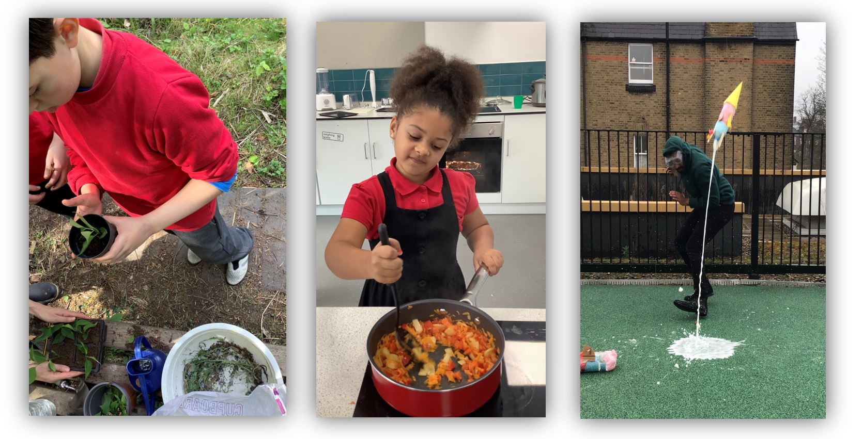
Children learn through an exciting curriculum which seeks to inspire them as confident and independent learners. We are committed to children’s learning, progress and high achievement, whilst also ensuring we provide relevant and enjoyable experiences for our children. We aim to foster their long-term development, our school providing a safe, inclusive and friendly environment that ensures every child receives the best possible start on their life-long learning journey.

Our Vision

At Tufnell Park every child flourishes into a resourceful, resilient and responsible citizen, developing the knowledge, skills and attributes required to thrive in the wider world.

Children experience a rich, purposeful and balanced curriculum, enhanced by a range of cultural, artistic, sporting, civic and real-life experiences to broaden their horizons, through the Tufnell Park Promise. Staff and children strive for excellence in all areas, leading to the school becoming the first choice for parents in the area.

Our school community have identified two particular aspects of learning to prepare our children for future success. The intention is that all children become:

- Skilled and discerning users of technology, developing their own creativity and ingenuity to enhance their learning and solve real world questions and problems

- Passionate, knowledgeable advocates for the natural environment, for sustainable practices, and for healthy, active lifestyles

EYFS Class Teacher

Contract:  Permanent | Hours:  Full time
Salary Scale:  Main Scale 1 – 6 | Actual Salary:  Dependent on teaching scale and experience
Start Date: September 2026

EYFS Teacher – Join Our Early Years Team

We are looking for a passionate, nurturing, and skilled teacher to join our Early Years team and help create a joyful start to children’s learning journey. This is an exciting opportunity for someone who is committed to high-quality Early Years education, inclusive practice, and ensuring every child thrives in a safe, stimulating, and inspiring environment. You will play a key role in delivering outstanding nursery provision, supporting children’s development through play-based learning, and working closely with families and colleagues to secure the very best outcomes for all children.

What We Offer
- A warm, welcoming, and supportive Early Years team
- A well-resourced environment designed to inspire curiosity and independence
- Strong commitment to high-quality professional development and continuous learning
- Opportunities to work closely with experienced leaders in EYFS and SEND
- A school community that values inclusion, nurture, and child-centred practice
- A collaborative culture where staff wellbeing and professional growth are prioritised
- The chance to make a real difference in children’s earliest and most important learning experiences
- Strong partnerships with families and external professionals to support every child’s success
- Leadership that values reflective practice, creativity, and innovation in teaching
What We Are Looking For
- A qualified teacher with strong experience in Early Years (Nursery/Reception)
- Excellent understanding of child development for children aged 2–5 years
- A passion for play-based learning and creating engaging learning opportunities
- Strong adult–child interactions that promote language, confidence, and independence
- Dedicated to supporting pupils with SEND and additional needs, working imaginatively and with a strong commitment to inclusion to ensure every child is given the opportunity to thrive academically, socially, and emotionally
- Skilled in observation, assessment, and using this to inform next steps in learning
- A reflective practitioner who can adapt teaching to meet individual needs
- Someone who values strong relationships with families and works collaboratively with colleagues
- Commitment to safeguarding, inclusion, and high expectations for every child
- A positive, enthusiastic, and nurturing approach to supporting young children

Visits to the School are welcomed and encouraged. Email at admin@tufnellpark.islington.sch.uk.

Also, do explore the website for videos, virtual tours and information, to find out what makes us special.

How to apply:
To apply for this post, please visit: https://feeds.trac.jobs

For an informal discussion about the role, please contact the school directly. Please note CVs are not accepted in line with Safer Recruitment practices.

Closing date for application: 9am on Wednesday 13th May 2026
Selection: Friday 15th May 2026 – before 3:30pm
Interviews: Wednesday 20th and Thursday 21st May 2026

Tufnell Park is committed to safeguarding and promoting the welfare of children and young people, and expect all staff and volunteers to share this commitment. An enhanced DBS (Disclosure and Barring Service) with barred list check will be required. In addition, if this post is likely to come under the requirements of the Childcare (Disqualification) 2009 Regulations and the successful applicant will be required to declare.

In line with KCSIE 2025 and safer recruitment practices, the school will conduct an online search for all shortlisted candidates. The online search is part of our safeguarding checks and will seek publicly available information on candidates’ suitability to work with children. Shortlisted candidates will be provided with further guidance and will be asked to clarify their online presence.

Please note the advertised actual salary is a range based on continuous service, with the maximum range indicating 5+ continuous years with local government/schools. The starting salary will be calculated based on the individual circumstances of the successful candidate/s.


Job Description

POSITION  HOURS  MANAGED BY  GRADE | EYFS Class Teacher  Tufnell Park Primary School  Headteacher  Main Scale Pay Range 1-6

PURPOSE OF THE POST

To provide high-quality teaching and learning within the Early Years Foundation Stage (EYFS), creating a safe, nurturing, and inclusive environment where every child can thrive. The teacher will support children’s learning and development through play-based, child-centred practice, with a strong focus on communication, independence, inclusion, and early identification of additional needs

DUTIES AND RESPONSIBILITIES

Teaching, Learning and Professional Practice

Deliver high-quality teaching and learning within the Nursery setting in line with the Early Years Foundation Stage (EYFS) framework.

Plan and provide engaging, play-based learning opportunities that promote curiosity, independence, and a love of learning.

Build strong adult–child interactions that support language development, sustained shared thinking, and emotional security.

Demonstrate a strong understanding of child development for children aged 2–5 years.

Observe, assess, and track children’s progress accurately to inform next steps in learning.

Create an enabling environment that supports exploration, creativity, and child-initiated learning.

Maintain and promote positive behaviour and respect for others among pupils, sharing understanding of the school’s rules and values.

Teachers will work in liaison, contact and co-operation with:

other members of staff;

members of borough support and advisory services;

organisations and networks relevant to the teacher’s duties;

parents, governors and the local community.

Teachers will work within the framework of:

national legislation, including Education Acts from 1944 to 1993, the SEN Code of Practice

and the School Teachers’ Pay and Conditions Act 1991;

school policies and guidelines on the curriculum and school organisation;

LEA policies and guidelines, in particular those relating to curricular aims and principles, and

to race and gender equality

2. SEND and Inclusive Practice

Ensure all children, including those with Special Educational Needs and Disabilities (SEND), are fully included and supported to achieve their potential.

Identify emerging developmental needs early and respond appropriately through effective support and intervention.

Adapt teaching, provision, and the learning environment to meet a wide range of individual needs.

Work closely with the SENCO, external professionals, and families to ensure appropriate provision and support plans are in place.

3. Adaptive Teaching and Responsive Practice

Adapt teaching and provision responsively based on children’s interests, developmental stages, and individual learning needs.

Use ongoing observation and assessment to shape next steps.

Provide both challenge and support to ensure progress for all learners.

Maintain an effective balance between adult-led teaching and child-initiated learning experiences.

4. Intervention and Targeted Support

Embed targeted support and intervention within daily provision rather than as isolated activities.

Use high-quality everyday interactions to reinforce communication, social development, early literacy, and early numeracy skills.

Plan and deliver small-group and 1:1 intervention where appropriate.

Monitor the impact of interventions and adapt strategies to ensure progress.

5. Communication and Partnership Working

Build positive, respectful relationships with children, families, and colleagues.

Communicate children’s progress, achievements, and next steps clearly and sensitively with parents and carers.

Work collaboratively with the wider EYFS team to maintain high standards across the setting.

Value and promote parental engagement as a key part of children’s learning and development.

Contribute positively to the wider life of the school and community.

6. Safeguarding and Professional Responsibilities

To promote the safeguarding of children, maintaining a strong understanding of safeguarding procedures and responsibilities across the whole school.

Ensure the Early Years environment is safe, stimulating, and emotionally secure for all children.

Follow all school policies and procedures, including safeguarding, behaviour, health and safety, and SEND.

Demonstrate professionalism, reliability, confidentiality, and reflective practice at all times.

Engage in continuous professional development to improve teaching and leadership across the whole school.

CONFIDENTIALITY

The nature of the job requires a high degree of initiative, confidentiality, tact and discretion when giving or receiving information, which could be confidential.

GENERIC DUTIES

To achieve high quality educational outcomes for children and personal appraisal targets as agreed with your line manager.

To undertake relevant training and development, including meetings, supervision, seminars and other events.

At all times carrying out responsibilities and duties in accordance with all relevant legislation, codes of practice and Tufnell Park’s policies and procedures.

To undertake additional duties commensurate with the grade as directed by your line manager.

The title of the post to which I normally report is: Headteacher

POST HOLDER DECLARATION:

Name:

Signed:

Date:

Person Specification

POSITION  SCHOOL  MANAGED BY  GRADE | Class Teacher  Tufnell Park Primary School  Headteacher  Main Scale Pay Range 1-6

Education and Experience
E1 | Qualified Teacher Status and evidence of appropriate subsequent in-service training.
E2 | Minimum of 2 years’ experience in an Early Years setting class, including at least one inner city multi-cultural school.
E3 | Proven experience of high standards of classroom practice
E4 | Respect for the views of parents and a commitment to the importance of the involvement of parents in the learning process.
E5 | Evidence of a commitment to excellence and the maximising of academic and personal achievement for all children.
Knowledge, Skills and Abilities
E6 | An understanding of the different ways in which children learn and the appropriateness of a variety of teaching styles to meet the individual learning needs of each child.
E7 | Evidence of the ability to successfully organise the curriculum for a class of children of mixed abilities, aptitudes and educational needs through planning, preparation, monitoring and assessment.
E8 | Evidence of adapting teaching and provision responsively based on children’s interests, developmental stages, and individual learning needs.
E9 | Evidence of good general knowledge of the requirements of the National Curriculum and learning strategies for children of all abilities.
E10 | Evidence of good organisational skills to create and maintain a stimulating and attractive learning environment.
E11 | Evidence of the ability to define effective measures for the performance of children in your care and to keep these measures under systematic review.
E12 | Evidence of knowledge and understanding of effective record keeping, and its use to promote the educational and personal development of all children within the school.
E13 | Evidence of the ability to maintain effective classroom discipline in a positive context and to promote well-ordered and self-disciplined behaviour throughout the school.
E14 | Evidence of good interpersonal skills and the ability to work as member of a team and develop and  maintain good relations with all members of the school community. To work co-operatively with  the staff of the Local Education Authority and relevant agencies as required.
E15 | Evidence of the ability to communicate clearly both orally and in writing with children, parents and colleagues.
E16 | An understanding of the responsibility of the class teacher with regard to the health and safety of children in their care.
E17 | Ability to form and maintain appropriate relationships and personal boundaries with children and young people.
Commitment to Equal Opportunities
E18 | Evidence of a commitment to an equal opportunities policy both in service delivery and employment, and an understanding of its effective operation within a school. An ability to ensure that each child’s identify is respected and maintained and enhanced and that stereotypes are challenged in a sensitive way.

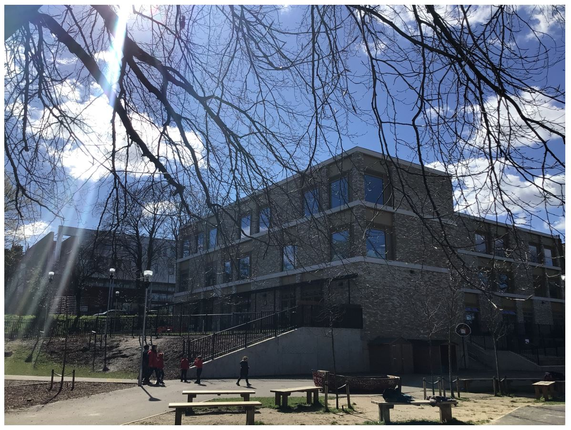

Visits to the School are welcomed and encouraged. Email at admin@tufnellpark.islington.sch.uk.

How to apply:
To apply for this post, please visit: https://feeds.trac.jobs

Closing date for application: 9am on Wednesday 13th May 2026
Selection: Friday 15th May 2026 – before 3:30pm
Interviews: Wednesday 20th and Thursday 21st May 2026

