
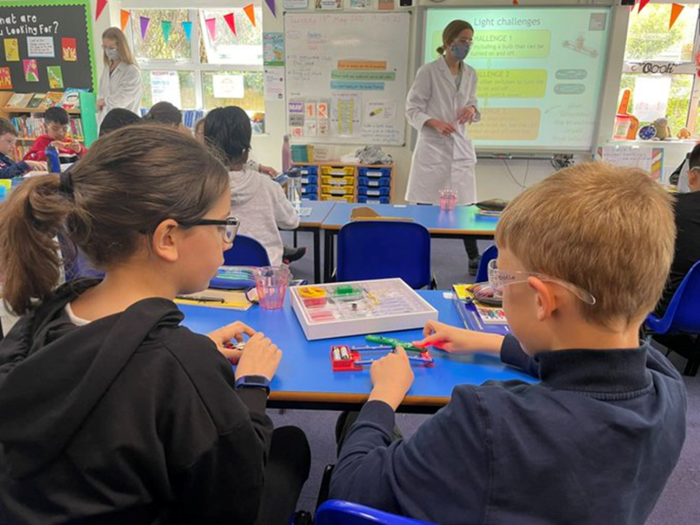

Headteacher JD and PS
Gospel Oak Primary School
Job Description
This job description should be read alongside the range of duties and responsibilities of Headteachers as set out in the annual Teachers’ Pay and Conditions Document. Candidates will be expected to have considered these in relation to Gospel Oak school.
Purpose
- To lead and manage within an agreed strategic framework so that the school is effective, self-managing, self-evaluating and self-improving and with high achieving pupils and staff.
- To move the school forward and provide a strong educational vision and leadership; to lead and co-ordinate the staff, to achieve the school aims in the context of the School Improvement Plan, and in full consultation with the Governing Body.

Accountability
- To be accountable to the Governing Body and the LA for the overall performance of the school and its day-to-day operation.

Safeguarding
- Maintaining a Safer Culture within the school and be committed to safeguarding and promoting the welfare of children.
- To embrace and advocate the 4 key aspects of safeguarding including protecting children from abuse and maltreatment, preventing harm to children’s health or development, ensuring children grow up with the provision of safe and effective care, and taking action to enable all children and young people to have the best outcomes.
- To employ effective child protection strategies and procedures to safeguard children.
- Ensure all recruitment and selection systems, training, processes and procedures are examined and adhered to from a child/staff safeguarding focus.

Relationships
- To establish, develop and maintain professional and productive working relationships with the Governing Body, staff, pupils and parents/carers, other schools, the Local Authority, businesses and community groups.
- To be responsible for the leadership and management of all school Staff.
- To maintain the positive ethos in the school in which individuals feel valued, and where personal endeavour and responsibility are encouraged.

Strategy and leadership
- With the Governing Body and other key stakeholders, to develop an agreed strategic plan and vision for the school that includes short, medium and long term targets and which is based upon secure and robust financial/resources planning.
- Show openness, passion and ambition for children.

Teaching and learning
- To implement and develop the whole curriculum agreed with the Governing Body.
- To adopt a broad cross-curricular approach which is child centred and provides access to real experiences.
- To develop, monitor, evaluate and improve the quality of teaching all pupils.
- To ensure achievement is improved and that challenging and motivating targets are set for individual pupils and the school.

Staff management
- To facilitate and support teaching and learning through maintenance and development of a high quality physical and learning environment.
- To ensure all staff understand the mission and ethos of the school, its current aims and objectives and their role in making sure they are fulfilled.
- To develop, support and encourage staff to achieve the highest professional standards while holding them to account through effective performance management.
- To maintain an open and effective professional dialog across all levels within the school thus raising staff morale and ensuring staff wellbeing.

Resources and management
- To be responsible for financial management which includes: the integration of financial planning and strategic and curriculum planning; the implementation and maintenance of secure procedures and systems; and adherence to all financial regulations of the Council.
- To recruit, retain, reward and motivate staff to achieve the objectives of the school.
- To develop and oversee a plan to ensure the effective and imaginative use of the school building and to lead on building improvements.

Interpersonal Skills
- To develop a flexible leadership and management style that is consistent with the ethos and culture of the school.
- To exhibit excellent communication skills including compassion, diplomacy and openness.
- To be professional, passionate, supportive, innovative, practical and ambitious for the school so all stakeholders feel engaged, encouraged, challenged, accomplished and fully involved in the life of Gospel Oak school.

Ethos
- To develop a positive ethos in the school in which individuals are encouraged.
  - To develop high morale and confidence and professional pride, and to set an example of professional standards and leadership.
  - To promote a suitable system of pastoral care for pupils and staff, including liaison with parents/carers/ guardians and outside agencies.
  - To maintain good behaviour, supported by policies and practices which promote self-discipline and responsible attitudes.
  - To foster and promote a sense of community within the school, including relationships with all pupils and parents/carers/guardians, and to further develop the strong links between the school and its wider community.
- To promote and sustain effective management of the school environment, its equipment site and buildings, to ensure that it offers a background which is safe and secure and conducive to learning.
- To promote and support the positive benefits of living within a culturally and ethnically diverse society, and to foster and sustain a positive approach to inclusion.

Inclusion
- To provide a strategic leadership and continuous commitment to the inclusion of all children.
- To ensure the entitlement of all pupils to have equal opportunity and access to all aspects of the curriculum.
- To actively promote equality of opportunity in the appointment and promotion of all staff.

Strengthening Community
- To be able to build a school culture and curriculum which takes account of the richness and diversity of the school’s communities.
- To create and promote positive strategies for challenging racial and other prejudice and dealing with racial harassment.
- To ensure learning experiences for pupils are linked into and integrated with the wider community.
- To ensure a range of community-based learning experiences.
- To co-operate and work with relevant agencies to protect children.

Person Specification
Qualifications and experience
- Qualified Teacher Status and evidence of appropriate subsequent in-service training and professional development.
- Substantial leadership experience in a senior post.

Knowledge
- Knowledge of what makes an effective school and strategies that can be deployed for school improvement.
- Knowledge of what constitutes good teaching and an understanding of how to improve the quality of teaching and learning.
- The ability to deliver a broad curriculum which is child centred and provides access to real experiences.

Skills
- Leadership skills including the ability to carry out strategic planning, involve and motivate others and articulate a vision and direction for the school.
- Able to develop people and hold them to account through informal and formal processes to ensure the best interest of the children are met.
- Management skills in respect of information and the use of performance data, finance and resources and people management – including delegation, monitoring and evaluating performance.
- Be a highly skilled listener and effective communicator, who is authentic, engaging and inspiring and who creates confidence in young children, current and potential parents, staff members, council officers or Governors.
- Able to develop and nurture partnerships and networks, realising tangible benefits
- Outward looking and curious, good networker and a leader with a strong business acumen.
- Effective skills and abilities to develop strategies and to manage a diverse school population.

Personal attributes
- Be tenacious, resilient and challenging, reflective, critical of received wisdom and not afraid to challenge the status quo.
- The ability to manage oneself, including time management, professional direction and development, and an ability to work effectively under pressure as part of a team.
- Commitment to equality of opportunity, diversity, safeguarding and social inclusion.
- The ability to deploy appropriate leadership and management styles and to act as a role model, establishing credibility with the governors, staff, pupils, parent/carers and the LA.
- To be innovative in their thinking, and able to inspire to make the school unique.
- To be approachable and fully involved in the daily life of the school.

Candidates are asked to demonstrate their ability to meet these selection criteria in their application form, their supporting statement and at the selection interview and any supporting exercises they may be asked to complete.

