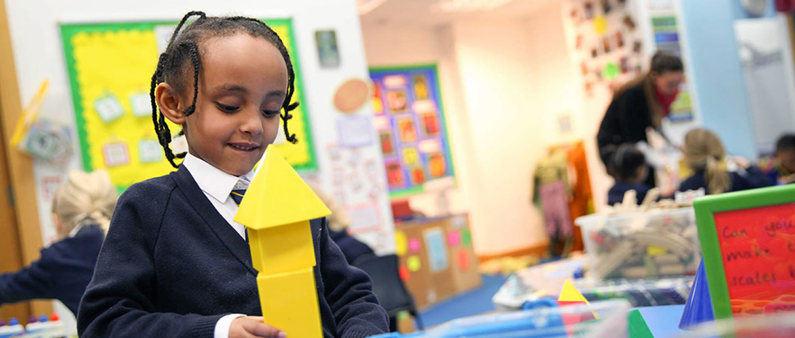
Receptionist/Admin Officer
St Peter and St Paul Catholic Primary School
Ref: SPSPAO/01
Closing date: 13th September 2026
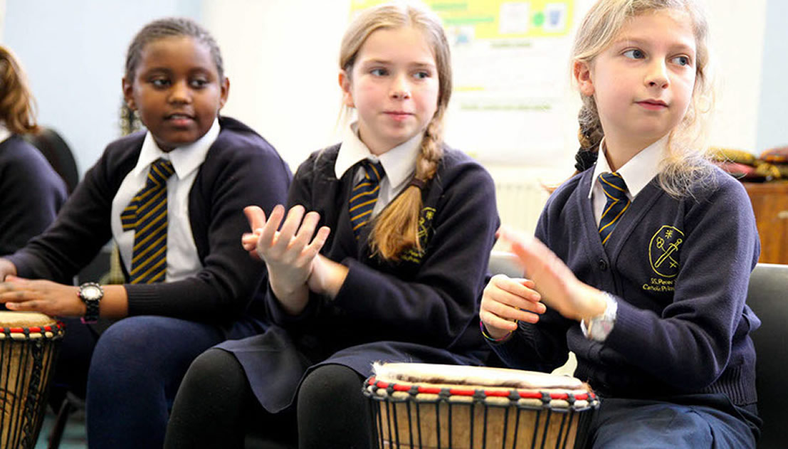
Contents

Letter from the Headteacher
About the school
Advert
Job Description
Person Specification
How to apply

Address- St Peter and St Paul Catholic Primary School,

Compton Street, Goswell road

London EC1 0EU

Email: admin@stpetersstpauls.sch.uk

Contact- Tel- 020 7253 0839

Letter from the Headteacher

Dear Candidate,
Thank you for your enquiry regarding the Admin Assistant vacancy at St Peter and St Paul Catholic Primary School. Please complete the online application, the job description and personal specification are below.
Closing date for applications is: 13th September 2026
Shortlisting/Interviews will be held: week 14th September 2026

St Peter and St Paul Catholic Primary School is committed to safeguarding and promoting the welfare of children and young people, and expect all staff and volunteers to share this commitment. This position is subject to enhanced Disclosure and Barring Service check.

In line with current safe recruitment guidelines, references will be taken prior to interview.
If you haven’t already done so, visits to the school are very welcome and can be arranged through the: admin@stpetersandstpauls.islington.sch.uk.
I look forward to receiving your application form.
Yours sincerely

Tracey Peters
Head teacher
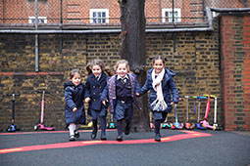
About the School

- Are you looking for a school that embodies their mission statement ‘To love one another’
- Do you put children at the forefront of every decision you make in school?
- Are you professional, approachable, enthusiastic and organised?
- Are you ready for an exciting new challenge?
- If so, then this could be the next job for you.
St Peter and St Paul Catholic Primary School is a one form entry primary school and nursery, between the Barbican area and Angel, Islington looking to recruit an admin assistant to join our team.

‘Leaders encourage pupils to develop a life-long love of learning here. Parents and carers typically said that the teachers are very helpful and that the school feels like a family.’

St Peter and St Paul Catholic Primary School was judged to be good by Ofsted at its last inspection in 2023. Stating that:

We will offer you:
- A caring, welcoming school where Christ is at the centre and underpins all that we do
- Amazing children who are engaged, enthusiastic and ready to learn
- A friendly, enthusiastic, ambitious and supportive staff
- A determined and passionate Head teacher and Senior Leadership Team
- A strong commitment to your professional development
- Supportive governors and parents

Admin Officer

Advert

- Grade: Scale 4 (Dependant on experience)
- Salary grade: £31,115 FTE

- Working Pattern: 25 hours per week (5 hours per day) 8.30am – 2pm including 30 minute lunch (TTO)
- Contract: Fixed -Term
- Required for September 2026 or sooner

St Peter and St Paul is a successful, one-form entry Catholic primary school situated in the vibrant and diverse borough of Islington. We strive to bring out the best in all of our pupils; they demonstrate an excellent attitude to learning and attain high academic standards. The Governing Body is seeking to appoint a highly motivated and creative admin assistant to join our team.

The successful candidates will:
- Support the Catholic ethos of the school
- Have high expectations of pupils and be excellent classroom practitioners
- Be able to communicate effectively with children, parents and staff
- Be able to work as part of a friendly and successful team

We offer:
- Enthusiastic, hardworking pupils who have ‘outstanding’ behaviour
- Supportive parents and School Governing Body
- Opportunities for continuing professional development

Job Description

To assist in the management of an effective, efficient and confidential administrative office in an education establishment. The post holder is required to be flexible in their approach to work with a positive attitude. Duties and responsibilities will include, but are not limited to, the following and may be altered at the request of the Head Teacher or School Business Manager.

- To provide the first point of contact for all visitors/callers to the school, welcoming them and providing information or referring them to the appropriate member of staff.
- To monitor daily registers and to undertake first line calling for absences
- To monitor access to the site ensuring visitors all sign in and out and are given badges as appropriate and to ensure all visitors are aware of safeguarding procedures, security and safety issues, including evacuation procedures.
- To answer the telephone and deal with general enquiries and pass on messages accurately as required.
- To manage the School’s admin account and re-distribute as necessary.
- To print and code invoices for entry on school’s finance system/create Purchase Orders on FMS
- To provide general office skills including photocopying, filing, data entry, and receipt and distribution of post.
- To complete basic weekly/monthly returns/records as appropriate.
- To enter and amend pupil data onto Arbor relevant computerised systems as well as hard copy files in line with GDPR.
- To deal with any enquiries, including admissions, following the schools admissions procedures.
- To respond with tact, sensitivity and awareness to pupils and parents in relation to duties undertaken.
- To take a personal responsibility for safeguarding and promoting the welfare of children.
- To undertake such other minor and/or non-recurring duties, appropriate to the post, as may be directed.

Personal Responsibilities
Job Description

- To be professional in dress and manner at all times.
- To monitor and manage your own workload and keep records in an agreed format.
- To ensure that all duties are performed in accordance with the Council’s Standing Orders and Financial Regulations.
- To carry out the duties and responsibilities of the post in accordance the School’s Health and Safety Policy and relevant Health and Safety Guidance and Legislation.
- To promote the safeguarding of children.
- To use information technology systems as required to carry out the duties of the post in the most efficient and effective manner.
- To undertake training and professional development as appropriate.
- To undertake other duties appropriate to the post that may reasonably be required from time to time.
- To undertake any CPD training regarding to all areas of the job’s responsibilities.

Person Specification

- Experience working in an office environment essential, ideally in a school.
- Five GCSE’s (or equivalent) including Maths and English.
- Competent IT skills, preferably Arbor, FMS, Microsoft Office and email systems.
- Ability to work under pressure and meet tight deadlines.
- Excellent interpersonal and communication skills, including face to face, on the phone and by letter.
- Ability to work with figures and produce relevant, accurate and detailed information.
- Ability to carry out general office skills including filing, emailing, distribution of post, photocopying.
- Excellent organisational skills, able to plan and manage own time effectively, work on own initiative.
- Ability to form and maintain appropriate relationships and personal boundaries with children and young people.
- Ability to maintain strict confidentially at all times.
- Ability to work effectively as part of a team and be able to respond flexibly to changing demands.

Application Deadline
How to apply
Completed application forms must be received by Midnight, 13th September 2026. Please note that we only accept online application forms. CVs, hard copy or late applications will not be accepted.

To apply
Please apply online at https://jobs.islington.gov.uk. If you need any assistance, please contact the school mariabennett@stpetersandstpauls.islington.sch.uk quoting reference SPSPAO/01.

Further enquiries
If you have read the job description and meet the essential requirements identified in the person specification, please apply on line. For an informal discussion of the role, please contact the Headteacher at the school contact number.

School visits
Visits to the school are very welcome and can be arranged through the School Office on 020 7253 0839 or mariabennett@stpetersandstpauls.islington.sch.uk

Completing your application
Please read the job description and person specification carefully. You should demonstrate on your application how you meet the requirements of the post according to your qualifications, skills, abilities and experiences. Please ensure to address each criteria of the person specification as this will be used to assess your suitability for the post.
Guidance notes on how to apply for a job within schools and the policy on the recruitment employment are available upon request. Please refer to those before submitting your application.

Shortlisting and selection procedure
The shortlisting and selection will be made by a panel of senior leaders. Shortlisted candidates will be notified immediately after shortlisting has taken place and will be provided with further information on the selection process.
We are planning the interview process to take place w/b 14th September 2026. The selection process may have a combination of tasks, activities, assessment tools and interview. Further information will be provided to the candidates shortlisted for interview.

Please would all applicants ensure that their preferred means of urgent contact (phone, mobile phone or e-mail) are clearly identifiable from the application form, so that your confidentiality is maintained.

References
Candidates are advised that references will be taken up during the shortlisting process. Candidates are asked to ensure that their referees are advised of the need to respond within the timescale set. In all cases at least two professional references are required.
The post will be offered subject to satisfactory completion of pre-employment checks.

Safeguarding children
Prior to appointment, formal checks will be made in accordance with the current statutory requirements relating to child protection.

