

Administration & HR Officer

(Term Time Only, 21 hours per week)

Closing Date: Midnight Sunday 1st November




Contents

Letter from the Head Teacher
Advert
Job Description
Person Specification
Guidance for candidates applying for a job with Islington Schools
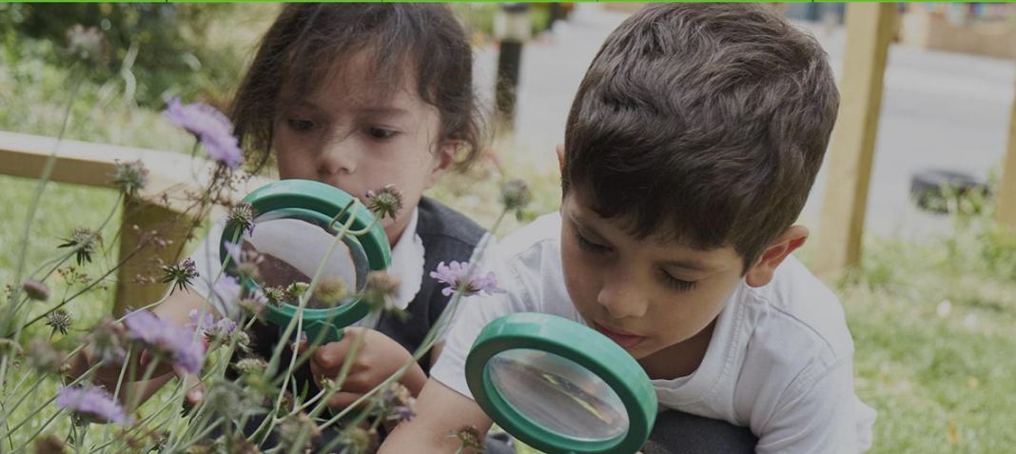
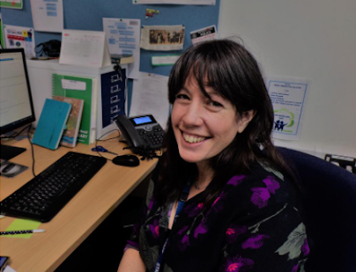

Letter from the Headteacher
Dear Potential Candidate
Thank you very much for your interest in the position of Administration and HR Officer at Moreland Primary School and Children’s Centre. Moreland is a unique provision providing excellent care and educational opportunities and outcomes to children from 6 months to eleven years in an amazing new building with spacious, well equipped grounds.
Moreland is part of the highly successful St Luke’s and Moreland Federation, a long -standing partnership which has gone from strength to strength. We are also a part of a very forward thinking collaboration of 24 schools called The Future Zone, which provides amazing opportunities for staff and pupils on various levels. We are located in a vibrant community at the heart of London and make the most of all the opportunities and local partnerships this offers us for children. There is exceptional energy and commitment on the part of the staff team and Moreland is an exciting, happy place in which to work and learn. The school’s ‘Learning for Life’ ethos is central to all we do and we are committed to high quality staff training and development.
Our children and families are at the heart of everything we do and we thrive on the diversity and wealth of culture, knowledge and experience that this brings to our school. We are committed to inclusion and all children in Moreland are valued as individuals and have the opportunity to excel. We actively nurture self-belief and Growth Mindset so children feel they can achieve anything with determination, perseverance and hard work. We aim to ensure that all barriers to learning are removed so every pupil reaches their own full potential. The leadership team, staff, children, parents and governors work together in Moreland with collaboration and mutual respect. We are united and learn from each other and succeed together.
'Reaching higher than I dreamed, becoming the person that I want to be, doing the best I can for the world and for me.’- this is our mission.
Please see the school website for information about the school. I would encourage you to come and see our wonderful school for yourself and visits are welcomed.
With best wishes,
Catherine Lawrence (Head teacher)

Why come to Moreland?

Information about the school
Moreland Primary School and Children’s Centre provides a seamless integrated service from pre-birth to the end of year 6. We have the privilege of working in a very rich and diverse community which includes many children and families from a range of backgrounds and cultures and this vibrant blend makes the Moreland community a unique and exciting place to work.
Why come to Moreland?
- The prospect of growing as a professional across a school and Children’s Centre
- Chance to work with other settings through the Federation and within the Future Zone and the opportunities this brings
- Opportunity to work in a setting with an inspiring curriculum
- Enticing Inner London pay rates
- Engaging and highly motivated team
- Highly supportive staff and dedicated governors
- Further Professional Development
- Excellent location at the heart of Islington and near the City of London
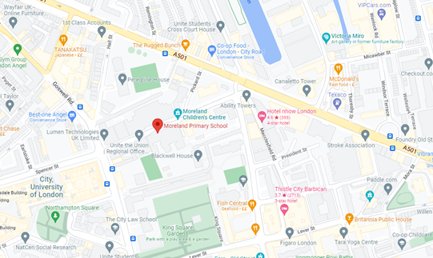
Moreland Primary School and Children’s Centre
Moreland Street
London
EC1V 8BB
Tel: 020 72538144

Ofsted Report
Latest reports on Moreland Primary School and Children’s Centre:
https://files.ofsted.gov.uk/v1/file/5028682
https://files.ofsted.gov.uk/v1/file/50280334
School Website
Moreland Primary School and Children’s Centre website:
https://www.moreland-islington.co.uk/


Job Advert
HR & Administration Officer
(3 days per week, Term Time Only)

HR & Administration Officer
3 days per week • Term Time Only (including INSET days)
Location: Moreland Primary School, Islington
Start date: 4th January 2027
Salary: S01 (Scale 23 -25) Actual Salary: £22093 - £22768
Moreland Primary School is seeking a highly organised, proactive and professional HR & Administration Officer to join our team. This is an exciting opportunity for someone with strong HR and administrative experience who thrives in a busy school environment and enjoys working with people.
Working closely with the School Business Manager and Headteacher, you will lead on key HR processes, support pupil admissions, and manage school lettings. You will play a vital role in ensuring our school runs smoothly and that staff, families and visitors receive a warm, efficient and professional service.
Key responsibilities include:
- Managing staff sickness absence, including leading sickness management meetings
- Liaising with Islington HR for advice and case management
- Leading on disciplinary processes as designated by the Headteacher
- Coordinating recruitment, onboarding and induction
- Supporting payroll administration and maintaining accurate personnel files
- Managing pupil admissions and liaising with the Local Authority
- Overseeing school lettings, bookings and invoicing
- Contributing to the smooth running of the school office
We are looking for someone who:
- Has HR administration experience (school experience desirable but not essential)
- Is highly organised with excellent attention to detail
- Communicates clearly and professionally
- Can handle sensitive information with absolute confidentiality
- Enjoys working as part of a team
- Is confident using IT systems and learning new processes
- If you are committed, efficient and enjoy making a positive difference behind the scenes, we would love to hear from you.

How to apply:
Please complete the online application form
Closing date: Midnight Sunday 1st November
Interviews: Week commencing 23rd November
www.moreland-islington.co.uk
Islington Schools are committed to safeguarding and promoting the welfare of children and young people, and expects all staff and volunteers to share this commitment. In line with KCSIE 2026 an online search will be conducted for shortlisted candidates in all positions.
Visits
Visits to the school are highly encouraged and can be organised by contacting the school office.
Tel: 020 7253 8144.
Email: admin@Moreland.islington.sch.uk
You can find out more about our school by accessing our website: www.morelandislington.co.uk.

Applications
To apply online, visit the jobs section at www.islington.gov.uk.
Closing date: Midnight Sunday 1st November
Shortlisting : Monday 2nd November
Interview dates: Week commencing 23rd November
Moreland Primary School and Children’s Centre is committed to safeguarding and promoting the welfare of children and young people, and expect all staff and volunteers to share this commitment.

Administration & HR Officer
(Term Time Only, 21 hours per week)

Grade: S01 (Scale 23 -25) Actual Salary: £22093 - £22768
Hours: 3 days per week/ 21 hours (open to flexible hours), term time only
Responsible to: School Business Manager / Headteacher
Location: Moreland Primary School and Children’s Centre

Job Description
Purpose of the Role
To provide high‑quality administrative and HR support that ensures the smooth and efficient running of the school. The postholder will lead on key HR processes, support pupil admissions, and manage school lettings, contributing to a professional, welcoming, and well‑organised school environment.
Key Responsibilities
1. Human Resources Administration
- Manage staff sickness absence, including monitoring, recording, reporting, and coordinating return‑to‑work processes.
- Lead sickness management meetings, ensuring accurate minute‑taking, timely follow‑up actions, and appropriate documentation.
- Liaise with Islington HR for advice, case management support, and escalation where required.
- Coordinate recruitment processes, including advertising vacancies, preparing recruitment packs, arranging interviews, and completing pre‑employment checks in line with safer recruitment requirements.
- Oversee onboarding and induction for new staff, ensuring all documentation, safeguarding checks, and training requirements are completed.
- Maintain accurate and confidential personnel files, ensuring compliance with statutory and school policies.
- Support the School Business Manager with payroll administration, including contract changes, timesheets, overtime, and liaising with payroll providers.
- Provide administrative support for disciplinary, capability, and grievance processes, including leading on disciplinary processes as designated by the Headteacher, ensuring accurate minute‑taking, secure record‑keeping, and timely communication.
- Maintain the Single Central Record (SCR) to the highest standard of accuracy and compliance.
2. Pupil Admissions
- Act as the first point of contact for new pupil admissions, providing clear communication to families and ensuring a welcoming, supportive process.
- Manage all admissions paperwork, data entry, and liaison with the Local Authority.
- Coordinate transition arrangements for new starters, including welcome packs and induction information.
- Maintain accurate pupil records and ensure compliance with statutory admissions guidance.
3. School Lettings Management
- Manage the lettings calendar, ensuring efficient scheduling and avoiding clashes with school events.
- Act as the key contact for hirers, providing information, processing bookings, and issuing contracts.
- Ensure all lettings comply with safeguarding, health and safety, and site security requirements.
- Monitor lettings income, prepare invoices, and support financial reconciliation.
- Organise the staffing of lettings and line manage lettings staff.
4. General Administration
- Provide high‑quality administrative support to the School Business Manager and leadership team.
- Respond to enquiries from staff, parents, and external agencies with professionalism and confidentiality.
- Keep up to date records of staff training ensuring the school is in compliance with all statutory training.
- Support the Headteacher in the management and administration of school policies.
- Provide website administration updating the website information and ensuring the website is compliant with statutory requirements.
- Support the smooth running of the school office, contributing to a welcoming and efficient front‑of‑house environment.
- Assist with data returns, reports, and compliance tasks as required.

5. Professional Responsibilities
- To actively follow all policies and take part in whole-school reviews of policies and policies as required.
- To evaluate and reflect on own practice and take on board advice given from monitoring and appraisal and act accordingly to address targets given.
- To actively participate in staff performance management procedures.
- To keep-up-to-date with best practice, current statutory requirements and policy through participation in CPD, training and meetings.
- To work collegiately with the admin team and the wider school team maintaining professional and productive working relationships.
6. Equalities
- To help ensure the environment, learning activities and resources reflect school policies relating to inclusion, equalities and diversity and that the implications of these policies are reflected in all tasks and duties listed above.

7. Personal Responsibilities
- To use information technology systems as required following the school’s policy for safe use of IT and pupil’s use of IT;
- To carry out the duties of the post in the most efficient and effective manner and to undertake training as appropriate;
- To undertake other duties appropriate to the post that may be reasonably required from time to time;
8. Performance Standards
- To ensure that all services within the areas of responsibility are provided in accordance with Moreland’s commitment to high quality service provision to the children and families;
- To take on board the school’s ‘Learning for Life’ ethos: which is relevant to children and to the staff team;
- At all times to carry out the responsibilities of the post with due regards to all of Moreland’s key policies including Safeguarding and Child Protection and Health and Safety.
9. Additional
- Be aware of key school plans, policies and procedures, especially the School Priorities, Health and Safety Procedures and Child Protection Procedures.
- Behave professionally and in compliance with the Code of Conduct
- To use and assist others in the use of information technology systems to carry out duties in the most efficient and effective manner.
- To achieve agreed service outcomes and outputs, and personal appraisal targets, as agreed by the line manager.
- To undertake training and constructively take part in meetings, supervision, seminars and other events designed to improve communication and assist with the effective development of the post and post holder.
- The post holder is expected to be committed to the Council’s core values of public service, quality, equality and empowerment and to demonstrate this commitment in the way they carry out their duties.
- Ensure all the services within the area(s) of responsibility are provided in accordance with the Council's commitment to high quality service provision to users.
- Ensure that duties are undertaken with due regard and compliance with the Data Protection Act and other legislation. In particular, respecting the confidentiality of pupil information and respond sensitively to pupils' needs.
- Carry out duties and responsibilities in accordance with the Council’s Health and Safety Policy and relevant Health and Safety legislation.
- At all times carrying out responsibilities/duties within the framework of the Council's Dignity for all Policy. (Equal Opportunities Policy).
Safeguarding Statement
Moreland Primary School and Children’s Centre is committed to safeguarding and promoting the welfare of children and young people, and we expect all staff and volunteers to share this commitment.
An ENHANCED DBS check is required for this post.
In line with Keeping Children Safe In Education 2026 an online search will be conducted for shortlisted candidates in all positions.

Policy and Legal Framework
The post holder will contribute to the smooth running of the school by following all policies and procedures including the staff hand book and Staff Code of Conduct and deliver the most recent national legislation, Education Acts, Keeping Children Safe in Education legislation, Prevent requirements, SEN Code of Practice and EYFS Framework.

Person Specification
The person specification is a picture of skills, knowledge and experience required to carry out the job. It has been used to draw up the advert and will also be used in the short-listing and interview process for this post.
You should demonstrate on your application form how you meet each of the following essential criteria. Please ensure that you address each one of the criteria as this will be used to assess your suitability for the post.

Education, Qualifications and Experience
E1 | Good standard of general education (GCSE English & Maths or equivalent)
D1 | HR‑related qualification (e.g. CIPD Level 3)
E2 | HR administration experience
D2 | Experience in a school setting
E3 | Managing sickness absence processes
E4 | Minute‑taking and handling confidential information
E5 | Coordinating recruitment and onboarding • Liaising with external HR providers (e.g. Islington HR)
E6 | Experience supporting disciplinary or capability processes
E7 | Administrative experience in a busy environment
D3 | Experience managing lettings or facilities bookings
Safeguarding
E8 | Display commitment to the protection and safeguarding of children and young people.
E9 | Up-to-date knowledge and understanding of relevant legislation and guidance in relation to working with, and the protection of, children and young people.
E10 | Will cooperate and work with relevant agencies to protect children.
Knowledge, Skills and Ability
E11 | Strong organisational skills
E12 | Excellent written and verbal communication
E13 | Ability to prioritise and manage workload independently
E14  E15 | High level of accuracy and attention to detail  Confident IT user (Microsoft Office essential)
D4 | Knowledge of safer recruitment requirements
D5 | Understanding of SCR maintenance
D6 | Familiarity with school MIS systems (e.g. Arbor, SIMS)
Personal Qualities
E16 | Professional, calm and approachable manner
E17 | Discreet and trustworthy with sensitive information
E18 | Positive team player
E19 | Flexible and solution‑focused
E20 | Able to build strong relationships with staff, parents and external partners
D7 | Interest in developing HR expertise within an education setting
Other Professional Skills
E21 | The ability to communicate clearly both orally and in writing and demonstrate good levels of literacy and numeracy.
E22 | IT skills commensurate with the requirements of the role.
E23 | Ability to mentor colleagues and support the professional development of others.
E24 | Willingness to undertake training
Commitment to Equal Opportunities
E25 | Demonstrate a commitment to equality and the ability to adhere to the Council’s Dignity for All policy.

