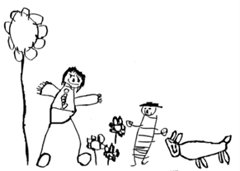

Margaret McMillan Nursery School and Children’s Centre
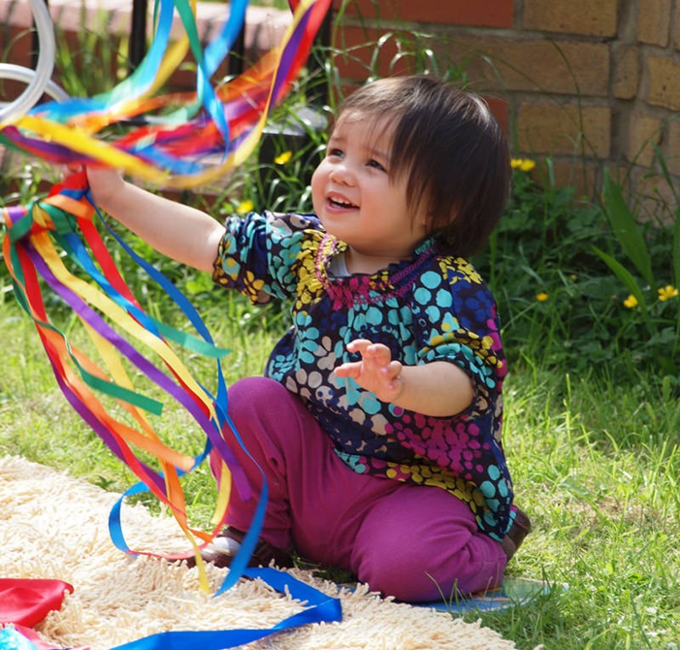
Early Years (Nursery) Class Teacher

Contents
Letter from the Headteacher 3
About Margaret McMillan 4
Key Facts 6
Advert 7
Job Description 9
Person Specification 12
How to Apply 14

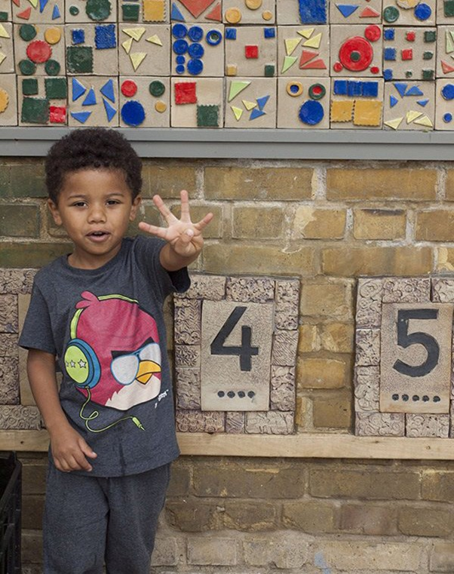

Letter from the Headteacher
Dear Candidate,
Thank you very much for your interest in the Class Teacher role at Margaret McMillan Nursery School and Children’s Centre.
We are looking to appoint an ambitious, enthusiastic, committed and inspirational Early Years Class Teacher to join our dedicated staff team. This post would be suitable for an Early Career Teacher (ECT) or an experienced teacher. You will be passionate about developing and delivering the best early years provision and ensuring the best possible start to life for our children. You will have responsibility for teaching and learning and have the opportunity to make a real difference to the outcomes of all children.
Margaret McMillan is a unique provision providing excellent care and educational opportunities and outcomes for children from 0 to 5 years within a carefully structured environment. We place a strong emphasis on the quality of the continuous provision as a basis for child-centred learning and have a well-established staff team of committed practitioners. We are proud to be an inclusive nursery school, offering a safe place to learn and play to some of the most vulnerable children in our community and celebrate and embrace the diversity and wealth of culture, knowledge and experience and all that this brings to our school.
The school operates the garden nursery model pioneered by Margaret McMillan, early last century, valuing the learning opportunities inside and outside equally. Our extensive outside learning environment is a hidden gem in North London, which promotes and extends children’s knowledge and interest for the natural world. Our school is committed to providing rich, inspiring and challenging learning experiences to our children both inside and outside. Please see the school website for more information about the school.
The school had two ‘Good’ OFSTED Inspections in October 2021 (School) and December 2022 (Day care) and we are really looking forward to the next steps in our journey to outstanding.
At Margaret McMillan, we have always been inspired by the children and aim to offer every child the very best start in life so that they can develop to make the best use of their talents and abilities.
If you are passionate about children’s early development, committed to improving your own practice, and want to work as part of a team, then this could be the job for you!
I would encourage you to visit - come and see our wonderful school for yourself!
Good luck with your application!
Best wishes,
Karen Smith (Head Teacher)

About Margaret McMillan

Vision and values
Margaret McMillan is a well-established nursery school with the child being the first consideration in everything we do. The school is committed to a child centred approach to learning within a carefully structured environment. We place a strong emphasis on the quality of the continuous provision as a basis for child centred learning. The staff collaborate closely to plan and deliver a broad and balanced curriculum within a rich and varied enabling environment. We have a strong commitment to team work which draws on a range of skills and expertise in order to observe and analyse children’s learning and provide a curriculum that meets their needs and interests. This commitment to team work extends throughout the school. The school operates the garden nursery model pioneered by Margaret McMillan early last century valuing the learning opportunities inside and outside equally.

Diverse community
Situated at the north end of Islington the children come from a variety of backgrounds, ethnic and socio-economic groups. The school is an established part of a community which benefits from a very wide social, racial and ethnic mix and a wide cultural diversity is shared and enjoyed. We celebrate and embrace diversity. Over the years the school has been a community resource providing education, day care, adult learning and children’s centre activities. All of our children are local children. The school provides safe space to learn and play for all children and families.

SEND
We work with a range of children with special educational needs and in addition have a well-established provision for children with profound and complex special needs. We strongly believe that inclusive provision should benefit all children. The school takes a proactive approach in identifying and supporting special need through well informed observation and interventions. We have excellent systems in place to support children, parents and staff as part of a fully inclusive programme throughout the school. We are very proud of our special needs work and see it as a strength of our school. Our teams have a wealth of experience and a positive attitude towards supporting children with special educational needs and disabilities (SEND). We have an ongoing programme of CPD. As an Islington school, we benefit from a local authority committed to inclusion with a proactive approach to SEND.

Team ethos
At Margaret McMillan we are an experienced and cohesive staff group committed to reflective practice to develop a relevant child-centred approach to high quality nursery education. We respond to the needs of the children through regular, well-informed and ongoing observation. We are a stable and supportive staff with a shared vision – always keeping the child at the centre of all we do!

Premises
The school is set in nearly an acre of garden, it is a well maintained and attractive space with bright open spaces and cosy corners. We place a high emphasis on ensuring all school resources are maintained to a high standard. All areas of the school are very well-resourced with high quality equipment and facilities. The school has applied rigour and attention to detail in choice of resources, organisation, presentation and layout. We have an exceptional enabling environment where the organisation and presentation facilitate the continuous provision throughout.

Partnerships
From the very beginning we work with parents to safeguard and support all the children within our community. We have very effective partnerships with parents. We offer a wide range of opportunities to for families to join us such as Maths Open morning, Arts and Crafts, Older Person Day, Teddy Bear’s Picnic and Den Building, as well as parent workshops, for example Toileting, Interactive Dads Workshop: Finger Gym. We have strong links with Adult and Community Learning and offer ESOL, maths and English classes. We collaborate with outside agencies including CAMHS and speech therapy professionals to support parenting.

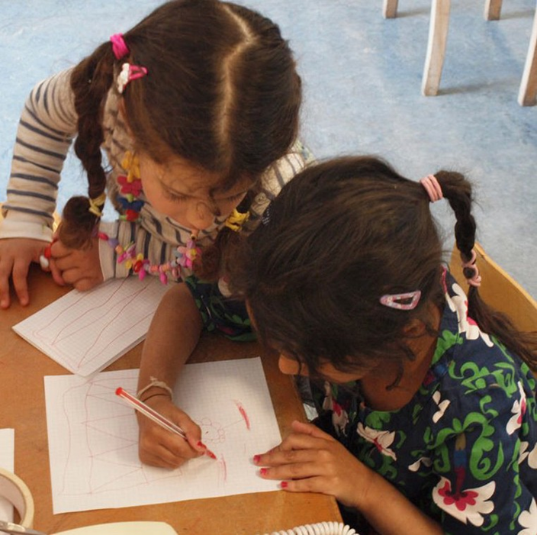

Key Facts
Margaret McMillan Nursery School is a local authority-maintained nursery school for children 0-5 years.
The school is an amalgamated site with provision for a separate baby room, dedicated day-care space and nursery class for 3 - 5 year olds. The day care is open 48 weeks per year over an extended day class provision is term time only. We are part of Islington Bright Start North Children’s Centre area. Some of the building is used for Children’s Centre activities such as CAMHS and adult and community learning.

Children
There are currently 93 children on roll places available:  - 0 - 2 year olds 9 children  - 2 - 3 year olds 32 children  - 3 - 4 year olds 52 children | - Number of Pupils in receipt of Early Years Pupil Premium – 35%  - Pupils with EAL 36%  - 17 different languages spoken

Staffing
22 staff employed directly and bought in professional services include IT support and premises management and maintenance. We buy other services from the borough, e.g. education library, HR and payroll.

Address
Margaret McMillan Nursery School and Children’s Centre
Hornsey Rise, London N19 3SF
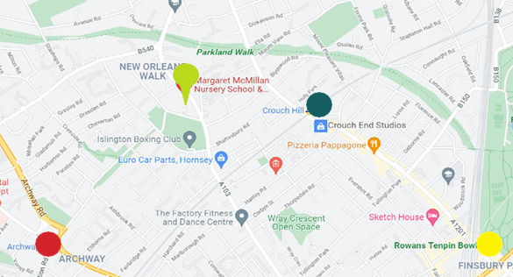 |  |  Archway   Finsbury Park   Crouch Hill

Advert

Early Years Class Teacher

Margaret McMillan Nursery School and Children’s Centre

Contract: | Permanent post, Term Time Only
Salary Range: | Inner London, MPS 1-6
Actual Salary Range: | £38,766 - £50,288
Start date: | September 2025

The Headteacher and Governors at Margaret McMillan Nursery School invite applications from ambitious, enthusiastic, committed, and inspirational Early Years teachers to join our dedicated staff team. You will be passionate about developing and delivering the best early years provision and ensuring the best possible start to life for our children.
This is an exciting opportunity to join the school and work with the Headteacher, the staff team, and the governors to realise the ambition.
The successful candidate will work in our Nursery Class (3-5 years old).
We are a school with:
- A strong commitment to high quality child centred nursery education
- An effective, stable, supportive and committed team
- A very well resourced and maintained learning environment
- An excellent outdoor environment
- Nursery education during term-time for children 2-5 year olds
- An established all year-round day-care programme for children 0-5 years
- Provision for children with profound and complex Special Educational Needs
- A commitment to working with parents as partners
- An excellent reputation for staff training
We are looking for a nursery teacher who is:
- A person who has a genuine passion for early childhood development.
- Able and support children to become active, independent thinkers and curious learners.
- Able to understand and be sensitive to the needs of every child.
- Committed to high standards of teaching and classroom practice.
- Able to work effectively as part of a team and establish positive relationships with pupils, parents, governors, and staff.

The school is set in nearly an acre of garden and operates the garden nursery model pioneered by Margaret McMillan early last century valuing the learning opportunities inside and outside equally. The school is committed to a child-centred approach to learning within a carefully structured environment. We place a strong emphasis on the quality of the continuous provision as a basis for child centred learning. We have a strong commitment to team work which extends throughout the school.
We kindly encourage you to visit us before applying.
Our Admin Team will be very happy to assist you booking a visit, just email: admin@margaretmcmillan.islington.sch.uk or call 020 7281 2745.
Apply at: | https://jobs.islington.gov.uk/
Closing date: | Monday 9 June 2025, 5pm.
Shortlisting date: | Tuesday 10 June 2025.
Interviews: | Monday 16 June 2025  (times of interviews will be confirmed with shortlisted candidates)

SAFEGUARDING AND EQUAL OPPORTUNITIES Margaret McMillan Nursery School is committed to safeguarding and promoting the welfare of children and young people and expects all staff and volunteers to share this commitment. An enhanced Disclosure and Barring Service check will be sought for the successful candidate. References will also be sought during the safer recruitment process to ensure your suitability to work with children.

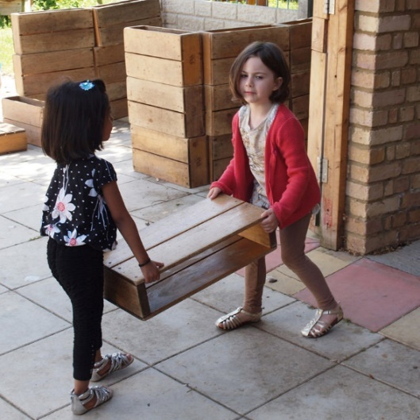 | 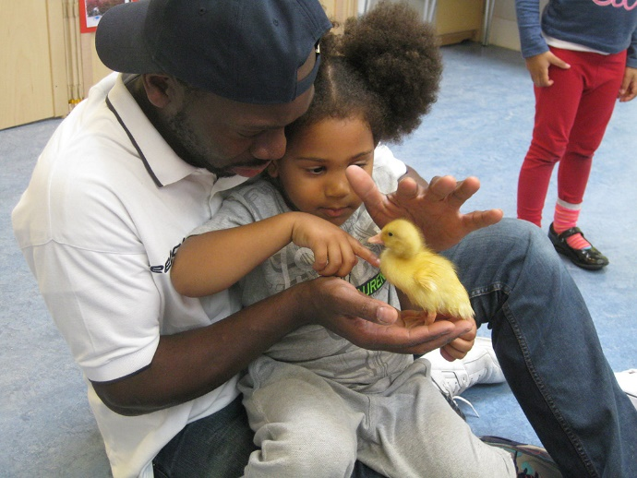

Job Description - Main Scale Early Years (Nursery) Class Teacher
Position | Nursery Class Teacher
Grade: | MPS 1-6 with QTS in line with the current School Teachers’ Pay and Conditions Document
Responsible To: | Headteacher
Supervisory responsibility | The postholder may be responsible for the deployment and supervision of the work of Early Years Practitioners and Teaching Assistants relevant to their responsibilities

This job description should be read alongside the range of duties of teachers set out in the annual School Teachers’ Pay and Conditions Document. Members of staff should at all times work within the framework provided by the school and Local Authority’s policy statements to fulfil the general aims and objectives of the school’s Education Development Plan.
Purpose of the post
To ensure the highest possible standards of education for the pupils for whom the teacher has class/group responsibility - socially, emotionally, physically, intellectually and aesthetically.
To ensure the appropriate levels of development for pupils within class group.
To assume continuity of policy and curriculum promoting equal opportunities for all.
To understand, follow and take responsibility for the safeguarding of all Early Years children, health and safety regulations and promoting good practice

DUTIES AND RESPONSIBILTIES
Teaching and learning
• Set high expectations which inspire motivate and challenge pupils to achieve their full potential.
• Promote good progress and outcomes by pupils establishing fair, respectful, trusting, and constructive relationships with them and their parents.
• Deliver a high quality Early Years Foundation Stage curriculum.
• Understand and be able to use a range of teaching, learning and behaviour management strategies to meet the needs of all pupils including those with special needs, high ability and those with English as an additional language
• Provide and use a stimulating, well ordered enabling environment to promote differentiated learning for all pupils.
• Understand and use a range of approaches to assessment, including formative and summative assessments that lead to progress and learning.
• Build on the prior knowledge and attainment of those they teach in order that pupils make sustained progress and become independent, motivated learners.
• Use assessment as part of their teaching to assess pupils’ needs, set realistic and challenging targets for progress and plan future teaching.
• Use local and national statistical information to evaluate the effectiveness of their teaching, to monitor the progress of those they teach and to raise levels of attainment.
• Provide pupils, parents and carers with timely, accurate and constructive feedback on pupils' attainment, progress and areas for development.
• Manage pupils’ behaviour constructively by establishing and maintaining a clear and positive framework for discipline, in line with the school's behaviour policy.
• Use a range of behaviour management techniques and strategies, adapting them as necessary to promote the self-regulation and independence of pupils.
Achievement and Diversity
• Understand how children and young people develop and how the progress, rate of development and well-being of pupils are affected by a range of developmental, social, religious, ethnic, cultural and linguistic influences.
• Make effective personalised provision for those they teach, including those for whom English is an additional language or who have special educational needs or disabilities, and know how to take practical account of diversity and promote equality and inclusion in their teaching.
• Understand the roles of colleagues such as those having specific responsibilities for pupils with special educational needs, disabilities and other individual learning needs, and the contributions they can make to the learning, development and well-being of children and young people.
• Know when to draw on the expertise of colleagues, such as those with responsibility for the safeguarding of children and young people and special educational needs and disabilities, and know how to refer to sources of information, advice and support from external agencies.
Health and well-being
• Know the current legal requirements, national policies and guidance on the safeguarding and promotion of the well-being of children and young people.
• Know the local arrangements concerning the safeguarding of children and young people and follow the safeguarding procedures.
• Identify and support children and young people whose progress, development or well-being is affected by changes or difficulties in their personal circumstances, and refer them to colleagues for specialist support as appropriate
• Establish a purposeful and safe learning environment which complies with current legal requirements, national policies and guidance on the safeguarding and well-being of children and young people so that pupils feel safe, secure and confident
Communicating and working with others
• Communicate effectively with children, young people and colleagues.
• Communicate effectively with parents and carers, conveying timely and relevant information about attainment, objectives, progress and well-being.
• Recognise that communication is a two-way process and encourage parents and carers to participate in discussions about the progress, development and well-being of the children. Recognise and respect the contributions that colleagues, parents and carers can make to the development and well-being of children and young people, raising their levels of attainment
• Have a commitment to collaboration and co-operative working where appropriate.
Personal and professional development
• Evaluate their performance and be committed to improving their practice through appropriate professional development.
• Have a creative and constructively critical approach towards innovation; being prepared to adapt their practice where benefits and improvements are identified.
• Act upon advice and feedback and be open to coaching and mentoring. Team working and collaboration
• Work as a team member and identify opportunities for working with colleagues, managing their work where appropriate and sharing the development of effective practice with them.
• Ensure that colleagues working with them are appropriately involved in supporting learning and understand the roles they are expected to fulfil.
PERSONAL RESPONSIBILITIES
• To carry out the duties and responsibilities of the post, in accordance with the school’s Health and Safety Policy and relevant Health and Safety Guidance and Legislation.
• To take responsibility for safeguarding and promoting the welfare of children.
• To use information technology systems as required to carry out the duties of the post in the most efficient and effective manner with due regard to GDPR
• To undertake training and professional development as appropriate.
• To undertake other duties appropriate to the post that may reasonably be required.
PERFORMANCE STANDARDS
• To ensure that all services within the areas of responsibility are provided in accordance with the school’s commitment to high quality service provision to the community.
• At all times to carry out the responsibilities of the post with due regard to the school’s Equal Opportunities and Inclusion policy.

Note
This job description is not your contract of employment or any part of it. It has been prepared only for the purpose of school organisation and may change either as your contract changes or as the organisation of the school is changed. Nothing will be changed without consultation.
Fundamental to fulfilling the responsibilities of this post is the ability to respond flexibly, positively and successfully to the ever-changing pressures which schools face. This job description is a guide to the level and range of responsibilities, which the postholder will initially be expected to undertake. It’s neither exhaustive nor inclusive and will be changed from time to time, so as to meet the changing circumstances and demands. It will not form part of the post-holder’s contract of employment.
Please note all successful candidates would be subject to an enhanced DBS check.
Margaret McMillan Nursery School and Children’s Centre is committed to safeguarding and promoting the welfare of children and young people, and expect all staff and volunteers to share this commitment.

Person Specification

Post Title: Early Years (Nursery) Class Teacher
Salary and Grade: Main pay scale range 1-6
You must demonstrate on your application form how you meet the following criteria.
Key : E – Essential D - Desirable | How it will be assessed?
Qualifications and Experience  - Qualified to degree level including Qualified Teacher Status  - Early Years specialist training  - To have teaching experience and understanding of Nursery aged children, including 2 year olds. | E  D  D | Application form  References  Interview
Professional Knowledge and Experience  - Excellent Teacher with a thorough understanding of the Early Years Foundation Stage and a commitment to the highest standards of teaching and learning  - A clear understanding of how young children learn and the ability to plan for effective and high quality teaching and learning in the Early Years Unit  - An understanding of the principles and practices of observations, assessment and planning and how these can be used effectively to maximise pupil progress for all groups of children  - To have experiences of working with children with SEND  - Experience and understanding of the key person role  - The ability to meet all children’s needs to ensure every child makes good progress including those with English as an additional language and children with additional or complex needs or disabilities  - To be able to manage behaviour effectively using a range of strategies.  - Experience of planning and organising an enabling learning environment inside and outside  - A positive approach to the outdoors and the ability to use the outdoor environment to support children across all areas of learning  - The ability to contribute to the development of an area of learning  - To lead by example through consistently high quality practice in all areas  - The ability to maintain professional and positive relationships with children, staff, parents and external agencies | E  E  E  E  E  E  E  E  E  D  E  E | Application form  References  Interview
Professional skills  3.1. To demonstrate the skills of an outstanding teacher, including the ability to:  - Use first hand experiences to interest, encourage and engage pupils  - Have very good behaviour management skills  - Provide appropriate levels of challenge so that all pupils make good progress  - Use assessment information effectively to plan next steps for children.  3.2. To work collaboratively and supportively with colleagues within Nursery, School, feeder schools and outside agencies  3.3. The ability to respond to challenges with optimism  3.4. To be committed to continual personal and professional development. To be reflective and learn from past experiences  3.5 To be committed to equality, diversity and the inclusion of all  3.6 To be able to communicate clearly both orally and in writing | E  E  E  E  E  E | Application form  References  Interview
Personal Characteristics  4.1. Have an excellent attendance record and be reliable with a high degree of integrity  4.2. Approachable with excellent interpersonal skills when dealing with others on all levels  4.3. Well-organised, enthusiastic, energetic and flexible  4.4. Resilient and demonstrates the ability to work under pressure. Manages time effectively  4.5. Values and respects the views of children  4.6. Self-motivated and able to take initiative and responsibility  4.7. A willingness to learn with and from colleagues  4.8. Proactive in maintaining own professional development and can seek help from others when needed  4.9. A commitment to take part in all aspects of the life of the School,  including meetings, training, special events and other activities as required  4.10. Adheres to the School’s Code of Conduct | E  E  E  E  E  E  E  E  E  E | Application form  References  Interview

Please note that appointments are a subject to successful pre-employment checks and clear DBS Enhanced Disclosure.

How to Apply

Application deadline
Completed application forms must be received by 5pm, Monday 9th June 2025.
Please apply online at https://jobs.islington.gov.uk
If you need any support, please contact the school.

Selection process
We are planning to shortlist on Tuesday 10th June 2025.
Interviews will take place on Monday 16th June 2025.
Shortlisted candidates will be provided with further information about the interview.

Visits
Visits to the school are highly encouraged and can be organised by contacting the school office on 020 7281 2745

References
Candidates are advised that references will be taken up immediately after shortlisting. Candidates are asked to ensure that their referees are aware of the need to respond within the timescale set. In all cases at least two professional references are required.
The post will be offered subject to satisfactory completion of pre-employment checks including references.

Safeguarding children
Prior to appointment, formal checks will be made in accordance with the current statutory requirements relating to child protection.

In line with KCSIE and safer recruitment practices, the school will conduct an online search for all shortlisted candidates. The online search is part of our safeguarding checks and will seek publicly available information on candidates’ suitability to work with children.
Shortlisted candidates will be provided with further guidance and will be asked to clarify their online presence.

